**Group HW: Problem 1, Earthquakes**

Here is some data on earthquakes of magnitude 2.5+ that occurred in the past 7 days:

<http://earthquake.usgs.gov/earthquakes/feed/v1.0/summary/2.5_week.csv>

It is a comma separated csv formatted text file with basic earthquake information such as source of earthquake (src), date, region etc.

(30 points) Write a function *earthquakeInfo(src)* which returns the total number of earthquakes that took place in the last 7 days, the number of earthquakes that took place yesterday and the number of earthquakes that originated at *src* For example,

*>>>earthquakeInfo(“ak”) Today’s Date: 2012-02-24*

*Total number of Earthquakes past 7 days: 205*

*Earthquakes yesterday 2012-02-23: 26*

*Earthquakes with source ak: 96*

*>>>earthquakeInfo(“us”) Today’s Date: 2012-02-24*

*Total number of Earthquakes past 7 days: 205*

*Earthquakes yesterday 2012-02-23: 26*

*Earthquake with source us: 75*

(20 points) There is a similar file with information for ALL earthquakes in the last 7 days:

<http://earthquake.usgs.gov/earthquakes/feed/v1.0/summary/all_week.csv>

Modify the *earthquakeInfo* function to take an additional argument *magnitude* and produce the following output:

*>>>earthquakeInfo(“ak”,”3”)*

*Today’s Date: 2012-02-24*

*Total number of magnitude 3 Earthquakes in past 7 days: 205*

*Earthquakes with magnitude 3 yesterday 2012-02-23: 26*

*Earthquake with magnitude 3 and source ak: 96*

*>>>earthquakeInfo(“us”,”7”)*

*Today’s Date: 2012-02-24*

*Total number of magnitude 7 Earthquakes in past 7 days: 35*

*Earthquakes with magnitude 7 yesterday 2012-02-23: 1*

*Earthquake with magnitude 7 and source us: 0*

*>>>earthquakeInfo(“us”,”20”)*

*No earthquakes with magnitude 20 found.*

Note: The data on the Web site is dynamic, that is, the data will change almost hourly, so it’s best to use a static local copy of the data for testing your code.

*Hints: Look into* ***timedelta*** *class from* ***datetime*** *module for figuring out yesterday’s date.The string method* ***strip()*** *will be handy.*

**Group HW: Problem 2, Wikipedia Images**

(25 points) Re-write your code for browsing Wikipedia at random to use regular expressions to find links, instead of manually breaking the tags apart. This should actually end up much simpler than the original code! All of your links should be valid ones – you shouldn’t ever end up at the 404 page.

(20 points) Write an additional regular expression to find images on the page. Download all of the images to a folder called “wiki_pics”. You will have to create the folder manually. As with the CNN image problem, the downloaded images should keep their original file names. Your code should ONLY capture images – be careful, as there are other file types on Wikipedia.

(5 BONUS points) Use list comprehensions with your regular expressions so they take only 1 line of code each.

(5 points) Produce output like this (an actual random walk produce by my code):

**>>>**

**Where would you like to start? http://en.wikipedia.org/wiki/Inuit_art**

**How many jumps? 10**

**Jumping from : http://en.wikipedia.org/wiki/Inuit_art**

**Saving 50px-Question_book-new.svg.png to wiki_pics/**

**Saving 220px-PaQi_2.jpg to wiki_pics/**

**Saving Tyara_Mask.jpg to wiki_pics/**

**Saving 220px-Shoofly.jpg to wiki_pics/**

**Saving 220px-Inuitbasket.jpg to wiki_pics/**

**Saving Caribou_by_Osuitok_Ipeelee.jpg to wiki_pics/**

**Saving 30px-Commons-logo.svg.png to wiki_pics/**

**To : http://en.wikipedia.org/wiki/Template_talk:Indigenous_Peoples_of_Canada**

**Jumping from : http://en.wikipedia.org/wiki/Template_talk:Indigenous_Peoples_of_Canada**

**Saving 16px-Symbol_neutral_vote.svg.png to wiki_pics/**

**To : http://en.wikipedia.org/wiki/User_talk:Buzzzsherman**

**Jumping from : http://en.wikipedia.org/wiki/User_talk:Buzzzsherman**

**Saving 150px-Animated-Flag-Canada.gif to wiki_pics/**

**Saving Qxz-ad163.gif to wiki_pics/**

**Saving 37px-Nohat-logo-XI-big-text.png to wiki_pics/**

**Saving 43px-Wikipedia-logo.png to wiki_pics/**

**Saving 25px-Information.svg.png to wiki_pics/**

**Saving 220px-Coat_of_arms_of_Canada_rendition.svg.png to wiki_pics/**

**To : http://en.wikipedia.org/wiki/User_talk:Victor_falk**

**Jumping from : http://en.wikipedia.org/wiki/User_talk:Victor_falk**

**Saving 40px-Inkscape.svg.png to wiki_pics/**

**Saving 45px-CopyeditorIcon3.png to wiki_pics/**

**Saving 32px-Nuvola_apps_important_blue.svg.png to wiki_pics/**

**Saving CopyeditorIcon3.png to wiki_pics/**

**Saving 35px-Ambox_warning_blue.svg.png to wiki_pics/**

**Saving 42px-Ambox_warning_orange.svg.png to wiki_pics/**

**Saving 64px-Copyright-problem.svg.png to wiki_pics/**

**Saving 48px-Copyright-problem.svg.png to wiki_pics/**

**Saving 64px-Copyright-problem.svg.png to wiki_pics/**

**Saving 48px-Information_icon4.svg.png to wiki_pics/**

**Saving 40px-Information.svg.png to wiki_pics/**

**Saving 60px-Peacedove.svg.png to wiki_pics/**

**Saving 18px-Face-smile.svg.png to wiki_pics/**

**To : http://en.wikipedia.org/wiki/User:Accounting4Taste**

**Jumping from : http://en.wikipedia.org/wiki/User:Accounting4Taste**

**To : http://en.wikipedia.org/wiki/Wikipedia:File_Upload_Wizard**

**Jumping from : http://en.wikipedia.org/wiki/Wikipedia:File_Upload_Wizard**

**Saving 50px-Splitsection.svg.png to wiki_pics/**

**Saving 220px-Example.jpg to wiki_pics/**

**Saving 30px-Gtk-dialog-info.svg.png to wiki_pics/**

**Saving 15px-Gtk-dialog-info.svg.png to wiki_pics/**

**Saving 15px-Gtk-ok.svg.png to wiki_pics/**

**Saving 20px-Gtk-dialog-warning.svg.png to wiki_pics/**

**Saving 20px-Gtk-dialog-warning.svg.png to wiki_pics/**

**Saving 20px-Gtk-dialog-warning.svg.png to wiki_pics/**

**Saving Example.jpg to wiki_pics/**

**To : http://en.wikipedia.org/wiki/Wikipedia:Media_copyright_questions**

**Jumping from : http://en.wikipedia.org/wiki/Wikipedia:Media_copyright_questions**

**Saving 40px-Ambox_warning_yellow.svg.png to wiki_pics/**

**Saving 40px-Replacement_filing_cabinet.svg.png to wiki_pics/**

**Saving Imbox_content.png to wiki_pics/**

**Saving 40px-Replacement_filing_cabinet.svg.png to wiki_pics/**

**Saving 20px-Purple_arrow_right.svg.png to wiki_pics/**

**Saving 18px-Face-smile.svg.png to wiki_pics/**

**Saving 18px-Face-smile.svg.png to wiki_pics/**

**To : http://en.wikipedia.org/wiki/Special:SpecialPages**

**Jumping from : http://en.wikipedia.org/wiki/Special:SpecialPages**

**To : http://en.wikipedia.org/wiki/Special:CentralAuth**

**Jumping from : http://en.wikipedia.org/wiki/Special:CentralAuth**

**To : http://en.wikipedia.org/wiki/Main_Page**

**Jumping from : http://en.wikipedia.org/wiki/Main_Page**

**Saving Commons-logo-31px.png to wiki_pics/**

**Saving 35px-Mediawiki-logo.png to wiki_pics/**

**Saving Meta-logo-35px.png to wiki_pics/**

**Saving Wikibooks-logo-35px.png to wiki_pics/**

**Saving 47px-Wikidata-logo.svg.png to wiki_pics/**

**Saving Wikinews-logo-51px.png to wiki_pics/**

**Saving Wikiquote-logo-51px.png to wiki_pics/**

**Saving Wikisource-logo-35px.png to wiki_pics/**

**Saving Wikispecies-logo-35px.png to wiki_pics/**

**Saving Wikiversity-logo-41px.png to wiki_pics/**

**Saving 35px-Wikivoyage-Logo-v3-icon.svg.png to wiki_pics/**

**Saving Wiktionary-logo-51px.png to wiki_pics/**

**To : http://en.wikipedia.org/wiki/Portal:Current_events**

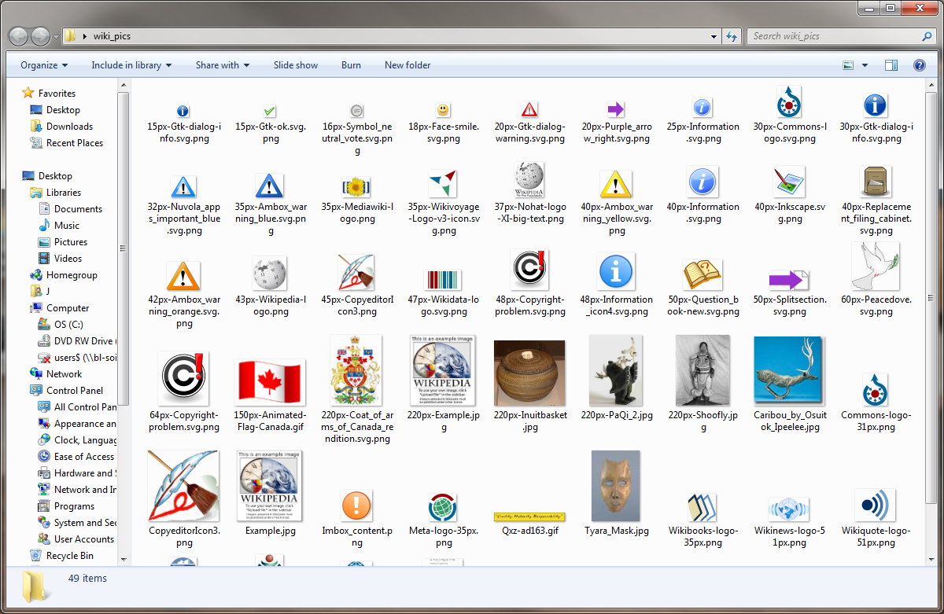

The images in wiki_pics:

**Submission**

Upload your program (.py) to Oncourse under Assignments -> Assignment 4 (Group) as two ***.py files***. Name your files ***YourUsername_A4_group_1.py,*** and ***YourUsername_A4_group_2.py***

e.g. If I were to upload, it would be johfdunc_A4_group_1.py and johfdunc_A4_group_2.py

Include the following information as a comment at the top of the file you submit:

• Your name

• Your group number

Make sure you submit a copy of the I211 Homework Team Feedback Form (found on Oncourse). You must submit a copy of this form with every homework or lose 50% of your grade!

**Each member of the group must submit their own copy of the homework!**

Test your code thoroughly!